**Project Design Phase-II**

**Data Flow Diagram & User Stories**

|  |  |
| --- | --- |
| Date | 03 October 2022 |
| Team ID | PNT2022TMID29836 |
| Project Name | CUSTOMER CARE REGISTRY |
| Maximum Marks | 4 Marks |

**Data Flow Diagrams:**

A Data Flow Diagram (DFD) is a traditional visual representation of the information flows within a system. A neat and clear DFD can depict the right amount of the system requirement graphically. It shows how data enters and leaves the system, what changes the information, and where data is stored

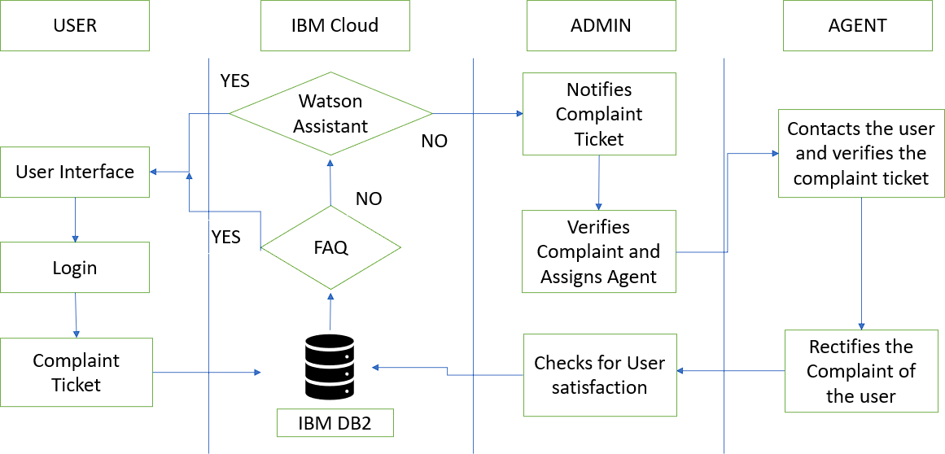

**User Stories**

Use the below template to list all the user stories for the product.

|  |  |  |  |  |  |  |
| --- | --- | --- | --- | --- | --- | --- |
| **User Type** | **Functional**  **Requireme nt(Epic)** | **User Story**  **Number** | **User Story / Task** | **Acceptance criteria** | **Priority** | **Release** |
| Customer  (Mobile user) | Registration | USN-1 | As a customer, I can register for the  application by entering my email, password,  and confirming my password. | I can access my account /  dashboard | High | Sprint-1 |
|  | login | USN-2 | As a customer, I can login to the application  by entering correct email and password. | I can access me  account/dashboard. | High | Sprint-1 |
|  | Dashboard | USN-3 | As a customer, I can see all the orders  raised by me. | I get all the info needed in  my dashboard. | Low | Sprint-2 |
|  | Order creation | USN-4 | As a customer, I can place my order with  the detailed description of my query | I can ask my query | Medium | Sprint-2 |
|  | Address Column | USN-5 | As a customer, I can have conversations  with the assigned agent and get me  queries clarified | My queries are clarified. | High | Sprint-3 |
|  | Forgot password | USN-6 | As a customer, I can reset my password by this  option in case I forgot my old password. | I get access to my account  again | Medium | Sprint-4 |
|  | Order details | USN-7 | As a Customer, I can see the current stats of order. | I get a better understanding | Medium | Sprint-4 |
| Agent  (Web user) | Login | USN-1 | As an agent I can login to the application by entering  Correct email and password. | I can access my account  /  dashboard. | High | Sprint-3 |
|  | Dashboard | USN-2 | As an agent, I can see the order details assigned to me by admin. | I can see the tickets to which I could answer. | High | Sprint-3 |

|  |  |  |  |  |  |  |
| --- | --- | --- | --- | --- | --- | --- |
|  | Address column | USN-3 | As an agent, I get to have conversations with  the customer and clear his/er doubts | I can clarify the issues. | High | Sprint-3 |
|  | Forgot password | USN-4 | As an agent I can reset my password by this option in case I forgot my old password. | I get access to my account  again. | Medium | Sprint-4 |

DATA FLOW DIAGRAM & USER STORIES

|  |  |  |  |  |  |  |
| --- | --- | --- | --- | --- | --- | --- |
| Admin (Mobil e user) | Login | USN-1 | As a admin, I can login to the applications by  enteringCorrect email and password | I can access my account/ dashboard | High | Sprint-1 |
|  | Dashboard | USN-2 | As an admin I can see allthe orders raised in the entire system and  lot more | I can assign agents byseeing those order. | High | Sprint-1 |
|  | Agent creation | USN-3 | As an admin I can createan agent for clarifying the  customers queries | I can create agents. | High | Sprint-2 |
|  | Assignment agent | USN-4 | As an admin I can assignan agent for each order created by | Enable agent to clarify the queries. | High | Sprint-1 |

|  |  |  |  |  |  |  |
| --- | --- | --- | --- | --- | --- | --- |
|  |  |  | the customer. |  |  |  |
|  | Forgot password | USN-5 | As an admin I can resetmy password by this option in case I forgot my old  password. | I get access to my account. | High | Sprint-1 |